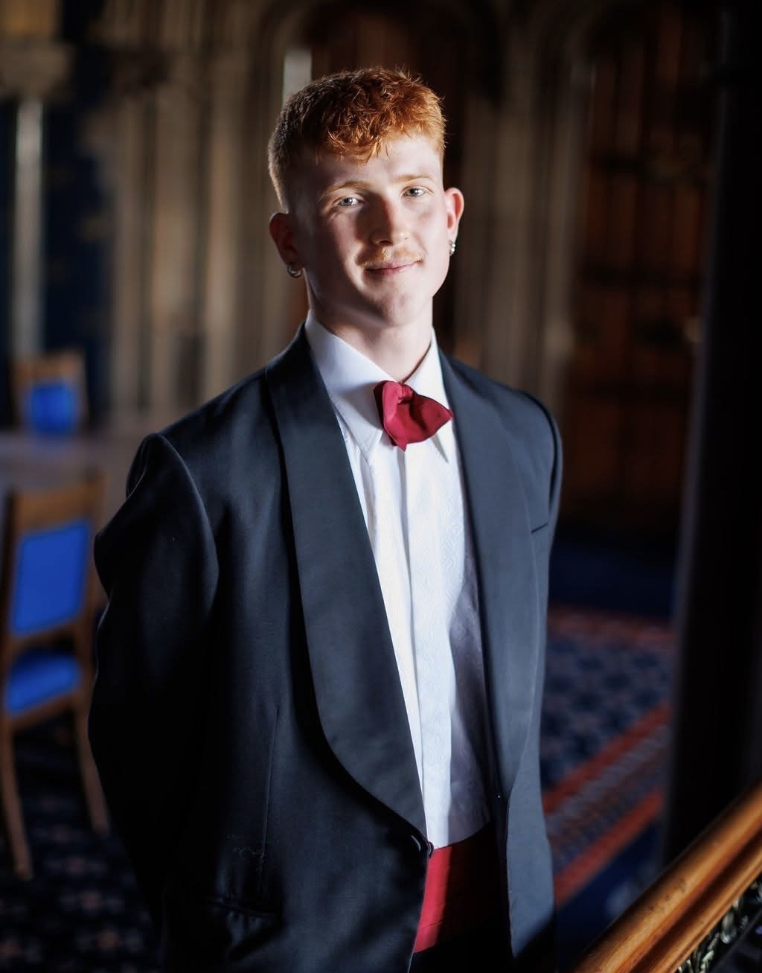

Duncan Calvert
SRC President

Duncan was elected to the Students’ Representative Council in spring 2024 as the School of Modern Languages and Cultures Rep and was then elected to be the SRC’s Court Assessor. He was then elected to the role of SRC President in spring 2025. In this role, he seeks to champion the values of the student body on Court.

Duncan is a graduate of MA Portuguese and Spanish, having joined the University in 2020. During this time, he undertook two periods abroad. He studied Portuguese Literature and History at the Universidade do Porto in Portugal and worked as an English Language Assistant in a high school in Barcelona, Spain.

He is also the President of the Catalan Society, serves on the board of the Portuguese Speaking Society and has volunteered as a Team Leader during the SRC’s Welcome Week.

