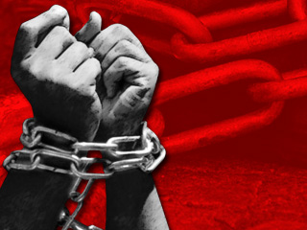

‘We hold these truths to be self-evident, that all men are created equal, that they are endowed by their Creator with certain unalienable Rights, that among these are Life, Liberty and the pursuit of Happiness.’
Abraham Lincoln

Overview

In 1863 Abraham Lincoln signed the Emancipation Proclamation in which he stated:
"I do order and declare that all persons held as slaves within said designated States, and parts of States, are, and henceforward shall be free".
This simultaneously ended one set of struggles for African Americans, yet began another: that of being recognized as free and gaining equality in America.
The impact of the practice of slavery does not belong to history but continues to resonate throughout the world today. By educating our learners to the issue of slavery we can enlighten them on many issues that affect the world, as well as reminding them of the terrible events that happened not so very long ago.

General Teaching

- Teaching learners about slavery is not the responsibility of one department, but should be taught from the perspective of different subjects. Slavery links directly to subjects such as History, RMPS, English, Art as well as many others. As such it can be taught in line with the expectations of Curriculum for Excellence.

- The study of slavery also teaches pupils about the aftermath of it and the legacy it has left on society. It can lead to discussions on race, equality, human rights, and the way in which people are treated in the world today.

- Scotland's role in the transatlantic slave trade is often overlooked yet is an integral part of how our society and country developed. Many people regard slavery as an American issue and fail to realise the part played by many Scottish merchants in contributing to, and thus benefiting from, it.

Teaching Slavery in the English Classroom

- Many of the texts taught in the English classroom deal with the issue of slavery either directly or indirectly. Popular novels such as Harper Lee's To Kill a Mockingbird or short stories such as William Faulkner's Dry September cannot be taught without first looking at their context through the history of slavery. By ensuring pupils have sound knowledge of the issue prior to reading these texts we can be confident that impact and significance of the literature is transferred to our learners.

Lesson 1: Introduction to Slavery

Lesson 1: Introduction to Slavery

Group Work Task

Prior to beginning work on this task, it would be beneficial to ascertain the pupils' prior knowledge on this topic.

Group Work Task

- In groups pupils will spend five minutes discussing the prompt questions on the task cards issued to them.

- Whole class feedback. Write the pupils' ideas in the board with the class copying into their jotters.

Introduce the focus of this project - Slavery in America

Teacher led discussion on the background to slavery in America.
Prompt questions could be used such as:
- When did this take place?
- Who were enslaved?
- When did it end?
- Was it only America involved?

These are not designed for in-depth discussion at this stage - but rather as a means of introducing the ideas that will be explored throughout the unit.

Teacher Note

After discussion get pupils to copy following into their jotters.

'The past isn't dead and buried. In fact, it isn't even past.' William Faulkner

Slavery, in one form or another, has existed as far back as records can recall. Slavery is the practice of owning people; that is treating them as though they were property and forcing them to work.

When we talk about slavery in the modern world, we are usually referring to
African slaves who were brought to the Caribbean and the Americas.

Group Discussion Cards - Task 1

In your groups discuss the following:
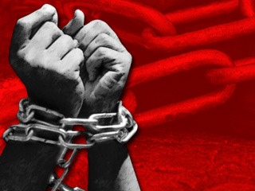
- What is slavery?

2. How did people become slaves?

3. Why did people want slaves?

4. Can you think of examples of times in history when slavery existed?

In your groups discuss the following:
- What is slavery?

2. How did people become slaves?

3. Why did people want slaves?

4. Can you think of examples of times in history when slavery existed?

In your groups discuss the following:
- What is slavery?

2. How did people become slaves?

3. Why did people want slaves?

4. Can you think of examples of times in history when slavery existed?

In your groups discuss the following:
- What is slavery?

2. How did people become slaves?

3. Why did people want slaves?

4. Can you think of examples of times in history when slavery existed?

Timeline
(Teacher's Copy)

Below is a timeline for the main events of slavery.

Rather than simply give a copy of this to the pupils it would be better to give them a blank timeline and fill it in together discussing the events with the class as you do so.
(You can amend this by adding in/taking out any of the main events)

1501 African Slaves in the New World: Spanish settlers bring slaves from Africa to Santo Domingo (now the capital of the Dominican Republic).

1562 John Hawkins, the first Briton to take part in the slave trade, makes a huge profit hauling human cargo from Africa to Hispaniola.

1581 Spanish residents in St. Augustine, the first permanent settlement in Florida, import African slaves.

1619 Africans brought to Jamestown (Virginia) are the first slaves imported into Britain’s North American colonies. Like indentured servants, they were probably freed after a fixed period of service.

1662 Virginia law decrees that children of black mothers "shall be bond or free according to the condition of the mother."

1705 Describing slaves as real estate, Virginia lawmakers allow owners to bequeath their slaves. The same law allowed masters to "kill and destroy" runaways.

1775 Anthony Benezet of Philadelphia founds the world’s first abolitionist society. Benjamin Franklin becomes its president in 1787.

1790—First United States Census Nearly 700,000 slaves live and toil in a nation of 3.9 million people.

1808 United States Bans Slave Trade. Importing African slaves is outlawed, but smuggling continues.

1857 The United States Supreme Court decides, seven to two, that blacks can never be citizens and that Congress has no authority to outlaw slavery in any territory.

1861-65 United States Civil War Four years of brutal conflict claim 623,000 lives.

1863 President Abraham Lincoln decrees that all slaves in Rebel territory are free on January 1, 1863. (Emancipation Proclamation)

1865 Slavery Abolished The 13th Amendment to the United States Constitution outlaws slavery.

Taken from Africa Online (http://www.africanaonline.com/2010/08/slavery-a-timeline/)

Timeline
Below is a timeline for the main events of slavery.
Working with the rest of your class complete this by filling in the main events.

1501

1562

1581

1619

1662

1705

1775

1790

1808

1857

1861-65

1863

1865

Background to Slavery

The people who were forced to become slaves were just ordinary people like you and I. The slaves brought from Africa were stolen away from their homes, friends, and family: their entire life.
Slaves were kidnapped from their villages, often by African slave traders who then traded the people for goods from the European merchants.

People were taken from their villages and gathered together near ports where the captain of the slave ship would keep them until he had enough 'cargo' to make his long journey worthwhile. All the time, the slaves had no real idea of what was happening to them, or where they would be taken.

Once on the ships the conditions were horrific. The journey to the Americas could take months and the people who worked on the ships did not care about looking after the African people. They were treated like animals not humans. The slaves were chained together and packed into very tight spaces as the captain wanted to fit as many slaves as possible onto his ship. Disease was high amongst the people because of the unhygienic conditions they were kept in, people did not get to use a toilet or wash, and as a result many people died on these journeys. When someone died their body was simply thrown overboard and they were fed to the sharks.

Once in America, their life as slaves really began. They were taken to auctions and there rich plantation owners would buy them to work for them. Slavery was mostly kept to the Southern States in America where people owned lots of land and needed workers for their business of growing things like tobacco and cotton.
The white buyers inspected the slaves in much the same way they would inspect a horse or other animal. They would look at things like the people's teeth and muscles to see how healthy and strong they were. Then the plantation owners would decide who they wanted to buy.
Families were torn apart as different buyers would want different people from a family. For example one person might buy a woman and someone else would buy her children. Many people were separated from their families never to see them again.

At the plantation life was hard. Slaves were forced to work under terrible conditions and received no pay. They would work long hours -often from sun up until sun down and they would be given very little to eat. Slaves were not allowed to rest if they got tired and they would be whipped for being 'lazy' if the overseer thought they were not working hard enough. Everyone endured the same conditions: men, women and children.
Slaves were expected to do many different jobs such as: work the land; cook; clean the main house; look after their owners' children; make furniture; tend to the animals; and generally do anything that they were told to do.

It was not just physically difficult for slaves but also emotionally. The people were in a strange country and often they did not understand English so could not communicate in their new environment. People were also taken from all over Africa so they may not even understand the other slaves as they spoke many different languages.
Slaves were also lonely as they had been taken away from their loved ones.

Some slaves would try to escape these shocking conditions, and although some managed to, very few really succeeded. If a slave was caught trying to run away he/she would be severely beaten and sometimes even killed, both as a punishment and as a warning to other slaves not to do the same thing.

Slave owners generally believed that slaves were not intelligent or capable of looking after themselves and so justified their behaviour as civilising the slaves. Others preferred to think of them more as animals than people. Some slave owners may have treated their slaves 'well' but at the end of the day they still enslaved human beings and denied them their dignity and freedom.

Background to Slavery
Worksheet

Understanding

Answer the following questions in sentences in your jotter.

- What happened to make people slaves?
- In your own words describe what conditions were like on a slave ship.
- In what way did the slave buyers and owners not treat slaves like people? Give an example from the text.
- What happened that made families become separated?
- Describe what life was like for a slave when they got to their new 'home'.
- Explain in your own words what happened to someone who tried to run away.
- What do you think was the worst part of slavery?

Language

Use a dictionary to find out the meaning of the following words. Once you have found the meaning copy both the word and its definition into your jotter.

merchant cargo unhygienic inspect
plantation overseer civilised dignity

Pair/Group Work

Make a list of any adjectives that would describe the slaves' feelings throughout this experience.

Choose three words and write a few sentences for each one explaining why you think they would have felt this way.

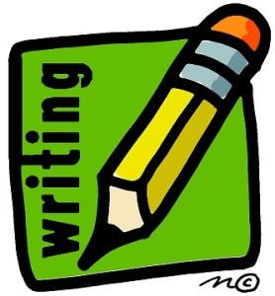
Background to Slavery
Worksheet

Written Assignments

Choose one of the following writing tasks.

- Diary Entry
Imagine yourself in the situation of one of the slaves.
Write a diary entry describing your thoughts and feelings on one of the following:

a) the day you have been taken from your village b) your first day at the plantation
c) a few months after becoming a slave

Using the information you have read to include ideas about your thoughts and feelings on: the plantation; your owner; the other slaves; your old home; your future.

- Personal
The slaves were clearly sad and frightened (amongst many other feelings) about their situation.

Write about a time when you experienced difficulty in your life.

Think about how you felt at the time and how you coped with the situation you were in.

Images of Slavery
Teachers' Notes

The following sheets are designed for use in a group work task.
Each group is given one sheet and are then allowed time to discuss the images they see using the prompt questions to guide their discussion.

At the end of the allocated time the group will report back to the class and open up the discussion on the images.

Below is an internet link for each of the numbered images. This means you can project each image to the class as the group is discussing it which will allow participation from other groups.

- http://www.bilerico.com/2008/02/middle%20passage.jpg

- http://www.bbc.co.uk/ahistoryoftheworld/objects/Akxq5WxwQOKAF5S1ALmKnw

- edb.utexas.edu

- http://historyscoop.wordpress.com/2010/11/02/images-from-a-slave-society/field-slaves/

- http://www.google.com/imgres?q=slave+auction&um=1&hl=en&tbm=isch&tbnid=MtDXCv82JK0_QM:&imgrefurl=http://niahd.wm.edu/index.php%253Fbrowse%253Dentry%2526id%253D9877&docid=N7kjN0YTeLArLM&w=679&h=563&ei=pQ48TqD8G4jHgAfh5uXOBg&zoom=1&iact=hc&vpx=407&vpy=519&dur=94&hovh=204&hovw=247&tx=95&ty=140&page=2&tbnh=142&tbnw=171&start=22&ndsp=23&ved=1t:429,r:7,s:22&biw=1280&bih=827

- live.drjays.com

- route40.net

- http://www.google.com/imgres?q=slave+houses&hl=en&tbo=d&gbv=2&tbm=isch&tbnid=lYFbc2SWM1KYNM:&imgrefurl=http://www.sanfranciscosentinel.com/%253Fp%253D35105&docid=diRCLrA1aE7tcM&w=515&h=369&ei=_tE6TvnsCLTr0QHw-4DWAw&zoom=1&biw=1024&bih=690

- dinmerican.wordpress.com

- melyjanex3.blogspot.com

Images of Slavery

Look at the images below and discuss what they make you think of.

- What do you see in the picture?
- Think about how the people in the pictures felt.
- Discuss how these pictures make you feel.
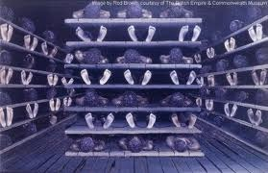

1.

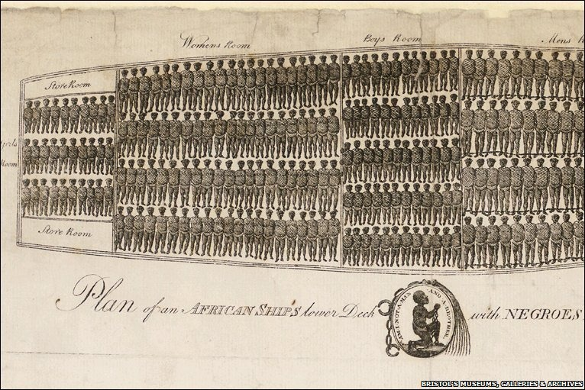
2.

Images of Slavery
Images of Slavery

Look at the images below and discuss what they make you think of.

- What do you see in the picture?
- Think about how the people in the pictures felt.
- Discuss how these pictures make you feel.
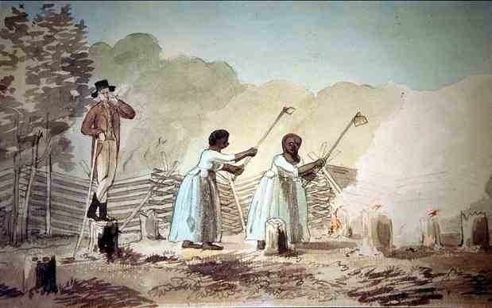
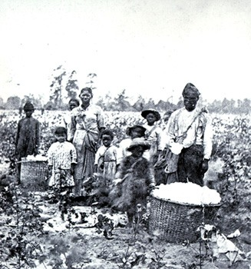
3.

4.

Images of Slavery
Images of Slavery

Look at the images below and discuss what they make you think of.

- What do you see in the picture?
- Think about how the people in the pictures felt.
- Discuss how these pictures make you feel.
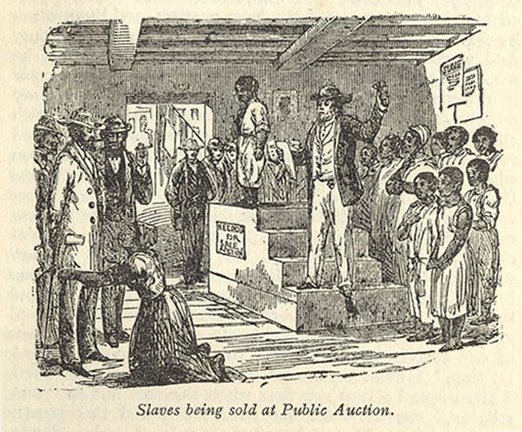

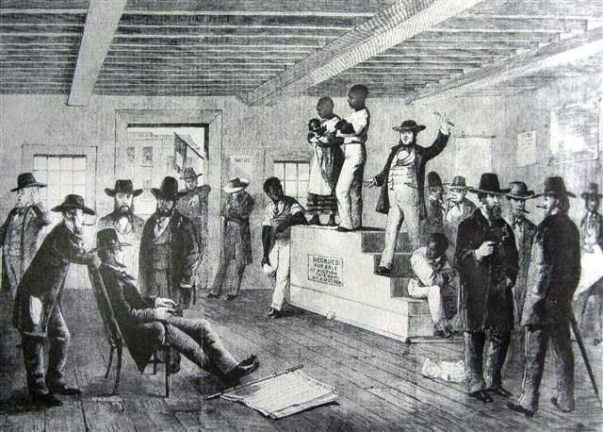
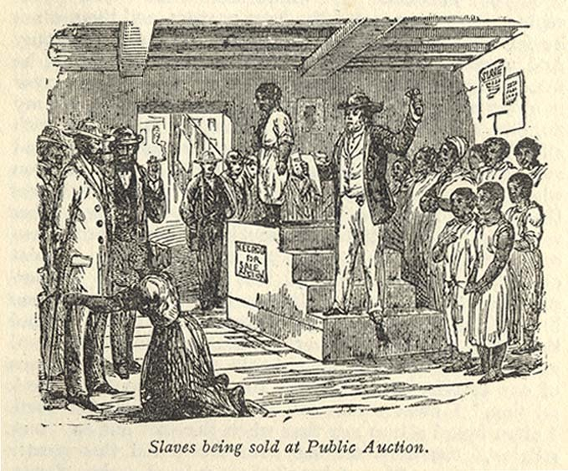
5.

6.

Images of Slavery

Look at the images below and discuss what they make you think of.

- What do you see in the picture?
- Think about how the people who would have lived here felt about their home.
- Discuss how these pictures make you feel.
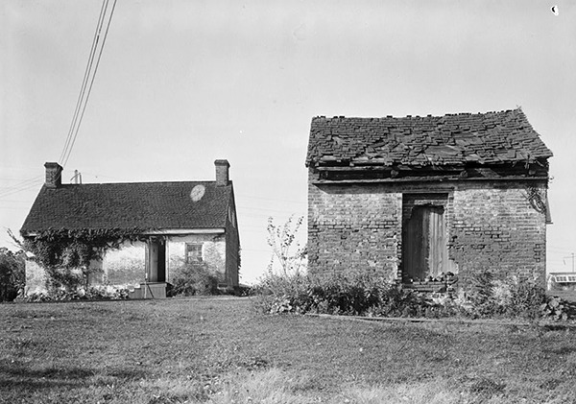

7.

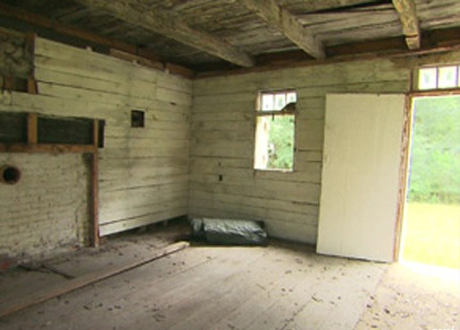

8.

Images of Slavery

Look at the images below and discuss what they make you think of.

- What do you see in the picture?
- Think about how the people in the pictures felt.
- Discuss how these pictures make you feel.
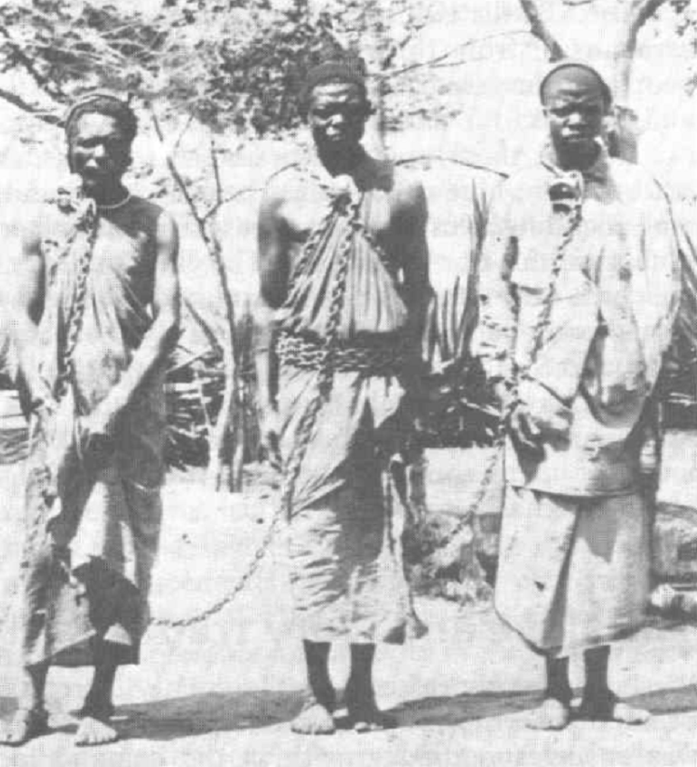
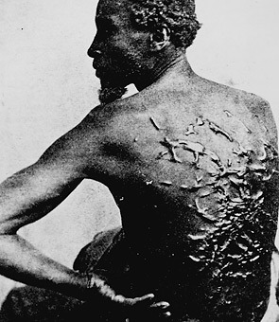
9.

10.

Runaway Ad

Description:
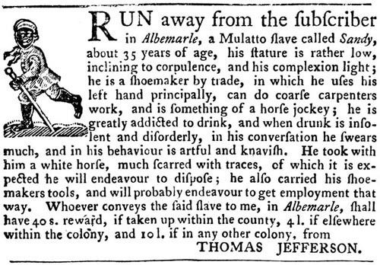
Jefferson ran this ad offering a reward for the return of "Sandy" in "The Virginia Gazette" on September 14, 1769.
Transcript:
RUN away from the subscriber in Albemarle, a Mulatto slave called Sandy, about 35 years of age, his stature is rather low, inclining to corpulence, and his complexion light; he is a shoemaker by trade, in which he uses his left hand principally, can do coarse carpenters work, and is something of a horse jockey; he is greatly addicted to drink, and when drunk is insolent and disorderly, in his conversation he swears much, and in his behaviour is artful and knavish. He took with him a white horse, much scarred with traces, of which it is expected he will endeavor to dispose; he also carried his shoe-makers tools, and will probably endeavor to get employment that way. Whoever conveys the said slave to me, in Albemarle, shall have 40 s. (shillings) reward, if taken up within the county, 4 l. (pounds) if elsewhere within the colony, and 10 l. if in any other colony, from
THOMAS JEFFERSON.
Credits:
Image courtesy Virginia Historical Society
http://classroom.monticello.org/teachers/gallery/image/226/Runaway-Ad/

Sale of Monticello Ad

Description:
Jefferson's grandson ran this ad announcing the public sale of Jefferson's personal property including "130 valuable negroes."
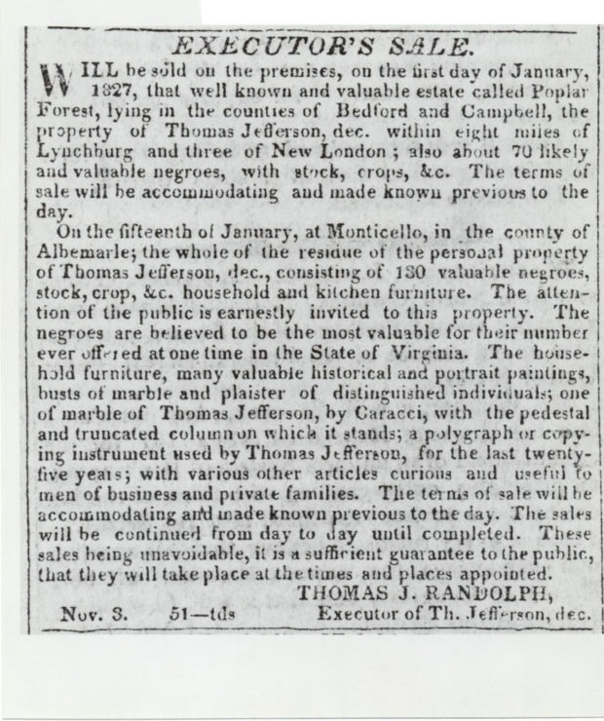

Transcript:
EXECUTOR'S SALE

Will be sold on the premises, on the first day of January, 1827, that well known and valuable estate called Poplar Forest, lying in the counties of Bedford and Campbell, the
property of Thomas Jefferson, dec. within eight miles of Lynchburg and three of New London; also about 70 likely and valuable negroes, with stock, crops, &c. The terms of
sale will be accommodating and made known previous to the day.

On the fifteenth of January, at Monticello, in the county of Albemarle; the whole of the residue of the personal property of Thomas Jefferson, dec., consisting of 130 valuable negroes, stock, crop, &c. household and kitchen furniture. The attention of the public is earnestly invited to this property. The negroes are believed to be the most valuable for their number ever offered at one time in the State of Virginia. The house-hold furniture, many valuable historical and portrait paintings, busts of marble and plaster of distinguished individuals; one of marble of Thomas Jefferson, by Caracci, with the pedestal and truncated column on which it stands; a polygraph or copying instrument used by the Thomas Jefferson, for the last twenty-five years; with various other articles curious and useful to men of business and private families. The terms of sale will be
accommodating and made known previous to the day. The sales will be continued from day to day until completed. These sales being unavoidable, it is a sufficient guarantee to the public, that they will take place at the times and places appointed.
THOMAS J. RANDOLPH
Executor of Th. Jefferson, dec.

http://classroom.monticello.org/kids/gallery/image/227/Sale-of-Monticello-Ad/
People as Property

Runaway Ad

- When would people normally make 'missing' posters in which they offer rewards? Think about why that makes this poster shocking.

2. How does Jefferson describe Sandy in negative way? Why do you think he does this?

3. What does Jefferson offer for Sandy's return? Why would this make it much more difficult for Sandy to escape?

'We hold these truths to be self-evident, that all men are created equal, that they are endowed by their Creator with certain unalienable Rights, that among these are Life, Liberty and the pursuit of Happiness.'

Thomas Jefferson is the author of these famous lines.

Discuss

Can you see any problems/contradictions between what is written here and the runaway advert?

Why would someone write 'all men are created equal' yet own slaves?
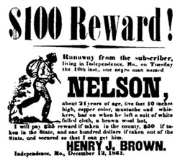

People as Property

Sale of Monticello Ad

Pair/Group work

Read through the advert in your groups.
Discuss your first reaction to this advert.

Written Work

- Copy out one of the sentences used to describe the slaves in this advert.
What is odd about the way they are described?

- Why would this be an anxious and frightening time for the slave sat Monticello?

- What do you think could happen to families and friends at the sale?

- How does an advert like this help you understand the way black people were treated at this time in America?

Discussion

Discuss and write down the feelings you think the slaves would have at this time.

How do you think they would feel if they saw this advert?
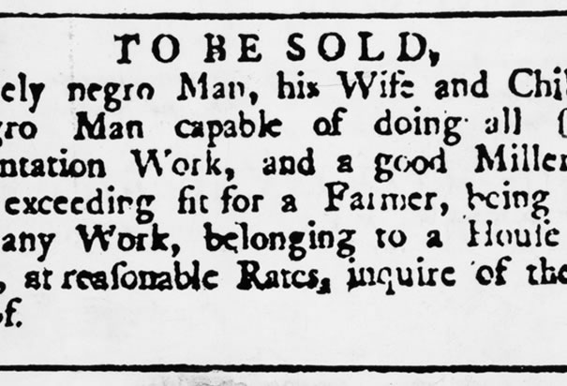

The End of Slavery

Research Work

In pairs/groups use either books or the internet to find out the answers to the following:

- When did slavery end in America?

- What events took place to bring about the end of slavery?

- Did everyone in America want slavery to end?

- List some of the ways that life continued to be difficult for black people in America after slavery was abolished.

Discussion

- Does slavery still exist in the world?

- If so, list some examples.
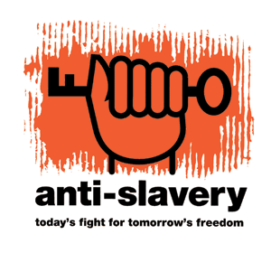
- How can we stop slavery in our world?

