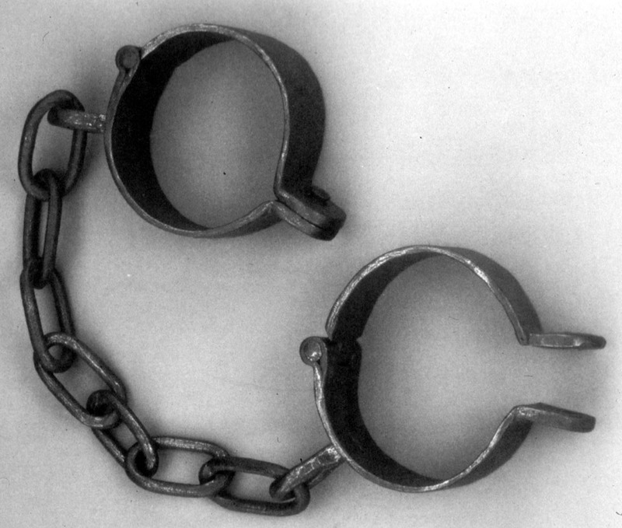

Unit created by A. Ford

Slave Narratives

We tend to learn about slavery through history books, novels or films. Although these texts give us information about this terrible time in history, they are often written by white people and not those who were the enslaved.
One type of text that gives firsthand account of slavery is slave narratives. These narratives are told by people who were directly involved in slavery and either escaped or gained their freedom and went on to tell their story.

Given the vast number of people who were enslaved in America, there are, unfortunately, very few of these narratives around.
There are many reasons for this.

- Many slaves could not read or write (in fact at one point it was illegal to teach a slave to read and write) therefore they had no means to record their stories

- Many white people were not interested in hearing of slaves’ experiences and so did not encourage the telling of them.

- By the time historians realised the value of recording the experiences of ex-slaves in the 1930s many of them had died, and those that were alive to tell their story had been very young when slavery ended. This means their account of life in slavery was limited to what they could remember from being a child.

- Because many of the narratives that do exist were dictated by the (ex) slaves and written down by someone else (often white) it is hard to differentiate between what the black person actually said and the details the writer added in or changed.

However, there are some slave narratives that were either written by the slaves themselves, or recorded verbatim. These are a great source of information on what life was like during slavery.

These narratives are informative, but they also put slavery into a human context, and convey the emotions of those involved in this atrocious act.

Websites for further reading

http://memory.loc.gov/ammem/snhtml/snhome.html

http://xroads.virginia.edu/~hyper/wpa/wpahome.html

Slave Narratives

Points to Consider

When analysing a slave narrative as literature there are certain techniques you need to be aware of.

- Authorship. Who wrote the narrative? Is the narrative written by the ex slave or was it dictated and someone else transcribed it? How does this affect the authenticity of the work?

- Point of view. This how the author allows you to see and hear what is happening. Does the author use first or third person narrative and how does this add to our engagement with the text?

- Tone. This is the author's attitude towards what he/she is writing about. Is the tone neutral; angry; containing elements of humour; etc and more importantly why has the author chosen to write in this tone?

- Style. Has the author employed a formal or informal style? In what way does the style of writing match or contrast with the writer's argument and story? You should also be aware of diction and syntax and how this affects your opinion of the author and his/her argument. (This last point is particularly pertinent to those narratives that were dictated by slaves and transcribed by someone else)

- Imagery/language. Does the author use a lot of imagery throughout his/her work? If so, then what does it add to the account. If there is an obvious lack of imagery and detailed language then what does it tell you about the author?

- Symbolism. Does the author use a recurring symbol to represent aspects of his/her life?

- Purpose. For whom and for what reason has the author written this piece? Is the writer simply using this as a way to remember the past or is there a political or social motive?

- Structure. Does the author follow a linear structure throughout the narrative or is the detailing of events out of sequence. Why has the author chosen to represent things in this way?

- Ideas. This is the point of the text - what the writer trying to tell you about. The writer may employ all or some of the above bullet points in trying to convey his/her ideas on the topic to you.

Fountain Hughes: Slave Narratives

Biography Transcript
Voice Over by Guy Johnson

Voice Over:

Fountain Hughes was born a slave in 1848 near Charlottesville, Virginia. He was the grandson of a slave owned by Thomas Jefferson, probably Wormley Hughes, Jefferson's gardener. Fountain was 101 years old at the time of his interview. Although enslavement for him was a long time gone, he never forgot what he had endured during his enslavery.

Excerpt:

Things come to me in spells you know, but I remember... I remember when we were slaves I was a little boy with no shoes. They didn't let us boys wear shoes. Boys never wore no shoes until they was 12 and 13 year old. You walk, you know... you walk and you be barefooted and cold. Many a time I stumped my toes and blood run out of 'em, but that didn't make them buy me no shoes and no pants either.

I wore a dress like a woman 'til I was... I believe then uh... 12, 13 year old. Didn't wear no pants. They didn't make pants for us boys, we wore dresses. 'Course we didn't have no beds when we were slaves. We always slept on the floor, a palette here and a palette there, and we didn't know nothin' 'cause they didn't allow you to look at no book.

It was just the same as we was in jail. I couldn't go from here 'cross the street 'out hav' a note or somethin' from my master. And if I had that pass -- that was what we called it, a pass -- if i had that pass I could go wherever he sent me and I have to be back you know and whoever he sent me to they'd give me another pass and I'd bring that back so as to show how long I'd been gone.

We couldn't just walk away like people do now you know... We were slaves we belonged to people and they'd sell us like they sell horses and cows and hogs and all like that. You wasn't no more than a dog to some of them in them days. You wasn't treated as good as they treat dogs now. I could say a whole lot more, but I won't. 'Cause it make people feel bad. You know. Makes me feel bad. All I know is if I thought that I'd ever be a slave again, I'd take a gun and just end it all. End it all.

Taken from:
http://www.moadsf.org/salon/exhibits/slave_narratives/fountain_hughes_t.html

Fountain Hughes: Annotation of Narrative

- Discuss the various techniques employed by writers of slave narratives.

- Play the narrative to the class and then discuss pupils' views on it.

- Pupils will work together to identify as many of the techniques as they can in the narrative.

- They will highlight these techniques and annotate the narrative with a note on the significance of the techniques(what they add to the narrative)

- Whole class discussion and feedback.

Resources required

- audio of narrative
- one copy per pupil of the text
- highlighters/pens to identify techniques

Israel Jeffferson: Narrative

Israel Jefferson, born in 1800, worked as a slave at Monticello. His parents, Edward and Jane Gillett, also served Jefferson as Monticello slaves. This memoir, assembled from Jefferson's interview with newspaperman S. F. Wetmore, was originally published in the Pike County Republican in December of 1873.

I was born at Monticello, the seat of Thos. Jefferson, third President of the United States, December 25--Christmas day in the morning. The year, I suppose was 1797.
My mother's name was Jane. She was a slave of Thomas Jefferson's and was born and always resided at Monticello till about five years after the death of Mr. Jefferson. She was sold, after his death, by the administrator, to a Mr. Joel Brown, and was taken to Charlottesville, where she died in 1837. She was the mother of thirteen children, all by one father, whose name was Edward Gillet. The reason for my name being called Jefferson will appear in the proper place.

After Mr. Jefferson had left his home to assume the duties of the office of President, all became quiet again in Monticello. But as he was esteemed by both whites and blacks as a very great man, his return home, for a brief period, was a great event. His visits were frequent, and attended with considerable ceremony. It was a time looked forward to with great interest by his servants, for when he came home many of them, especially the leading ones, were sure to receive presents from his hands.

Mr. Jefferson died on the 4th day of July, 1826, when I was upwards of 29 years of age. His death was an affair of great moment and uncertainty to us slaves, for Mr. Jefferson provided for the freedom of 7 servants only: Sally, his chambermaid, who took the name of Hemings, her four children-- Beverly, Harriet, Madison and Eston--John Hemmings, brother to Sally, and Burrell Colburn [Burwell Colbert], an old and faithful body servant. Madison Hemings is now a resident of Ross county, Ohio, whose history you gave in the Republican of March 13,1873. All the rest of us were sold from the auction block, by order of Jefferson Randolph, his grandson and administrator. The sale took place in 1829, three years after Mr. Jefferson's death.

I was purchased by Thomas Walker Gilmer, I married Mary Ann Colter, a slave, by whom I had four children--Taliola (a daughter), Banobo (a son), Susan and John. As they were born slaves they look the usual course of most others in the same condition of life. I do not know where they now are, if living; but the last I heard of them they were in Florida and Virginia. My wife died, and while a servant of Mr. Gilmer, I married my present wife, widow Elizabeth Randolph, who was then mother to ten children. Her maiden name was Elizabeth Farrow. Her mother was a white woman named Martha Thackey. Consequently, Elizabeth, (my present wife) was free-born.

My wife and I have lived together about thirty-five years. We came to Cincinnati, Ohio, where we were again married in conformity to the laws of this State. At the time we were first married I was in bondage; my wife free. When my first wife died I made up my mind I would never live with another slave woman. When Governor Gilmer was elected a representative to Congress, he desired to have me go on to Washington with him. But I demurred, I did not refuse, of course, but I laid before him my objections with such earnestness that he looked me in the face with his piercing eye, as if balancing in his mind whether to be soft or severe, and said,

"Israel, you have served me well; you are a faithful servant; now what will you give me for your freedom?"

"I reckon I will give you what you paid years ago--$500," I replied.

"How much will you give to bind the bargain?" he asked.

"Three hundred dollars," was my ready answer.

"When will you pay the remainder?"

"In one and two years."

And on these terms the bargain was concluded, and I was, for the first time, my own man, and almost free, but not quite, for it was against the laws of Virginia for a freed slave to remain in the State beyond a year and a day. Nor were the colored people not in slavery freed they were nominally so. When I came to Ohio I considered myself wholly free, and not till then.

I was bought in the name of my wife. We remained in Virginia several years on sufferance. At last we made up our minds to leave the confines of slavery and emigrate to a free State. We went to Charlottesville Court House, in Albemarle county, for my free papers. When there, the clerk, Mr. Garret, asked me what surname I would take, I hesitated, and he suggested that it should be Jefferson, because I was born at Monticello and had been a good and faithful servant to Thomas Jefferson. Besides, he said, it would give me more dignity to be called after so eminent a man. So I consented to adopt the surname Jefferson, and have been known by it ever since.

Since I have been in Ohio I have learned to read and write, but my duties as a laborer would not permit me to acquire much of an education. But such as I possess I am truly thankful, and consider what education I have as a legitimate fruit of freedom.

*
I well recollect a conversation he had with the great and good Lafayette, when he visited this country in 1824 and 1825, as it was of personal interest to me and mine. General Lafayette and his son George Washington, remained with Mr. Jefferson six weeks, and almost every day I took them out to a drive.

On the occasion I am now about to speak of, Gen. Lafayette and George were seated in the carriage with him. The conversation turned upon the condition of colored people--the slaves. Lafayette spoke indifferently; sometimes I could scarcely understand him. But on this occasion my ears were eagerly taking in every sound that proceeded from the venerable patriot's mouth.

Lafayette remarked that he thought that the slaves ought to be free; that no man could rightly hold ownership in his brother man; that he gave his best services to and spent his money in behalf of the Americans freely because he felt that they were fighting for a great and noble principle--the freedom of mankind) that instead of all being free a portion were held in bondage (which seemed to grieve his noble heart); that it would be mutually beneficial to masters and slaves if the latter were educated, and so on. Mr. Jefferson replied that he thought the time would come when the slaves would be free, but did not indicate when or in what manner they would get their freedom. He seemed to think that the time had not then arrived. To the latter proposition of Gen. Lafayette, Mr. Jefferson in part assented. He was in favor of teaching the slaves to learn to read print; that to teach them to write would enable them to forge papers, when they could no longer be kept in subjugation.

This conversation was very gratifying to me, and I treasured it up in my heart.

I know that it was a general statement among the older servants at Monticello, that Mr. Jefferson promised his wife, on her death bed, that he would not again marry. I also know that his servant, Sally Hemmings, (mother to my old friend and former companion at Monticello, Madison Hemmings,) was employed as his chamber-maid, and that Mr. Jefferson was on the most intimate terms with her; that, in fact, she was his concubine. This I know from my intimacy with both parties, and when Madison Hemmings declares that he is a natural son of Thomas Jefferson, the author of the Declaration of Independence, and that his brothers Beverly and Eston and sister Harriet are of the same parentage, I can as conscientiously confirm his statement as any other fact which I believe from circumstances but do not positively know.

(annotated version of the text)

"Life among the Lowly, No. 3," Pike County (Ohio) Republican, December 25, 1873.

Israel Jefferson: Narrative

Worksheet

Task 1

Annotate the text, highlighting and making notes on any techniques you can identify.

Task 2

In pairs/groups discuss the following techniques in more detail (and write out your ideas):

1. The purpose of the opening sentence.

2. Tone

3. Point of View

4. Purpose

5. Ideas

Task 3

Focus on the paragraph in bold. It details a discussion Israel overheard his master, Thomas Jefferson, and General Lafayette having regarding the issue of slavery.

Thomas Jefferson was thought by most to be a decent, if not good, slave owner.

- How does Israel convey Jefferson's views to slavery in this section

- Does Israel employ any techniques in his portrayal of Jefferson to the audience?

- What do you think was Israel's views on his owner?

- Israel states: 'This conversation was very gratifying to me, and I treasured it up in my heart.' Why do you think he feels this way?

