Using the Voyages Database – a step by step guide

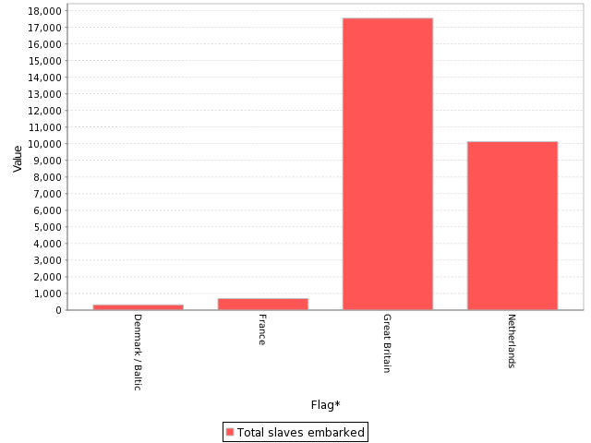
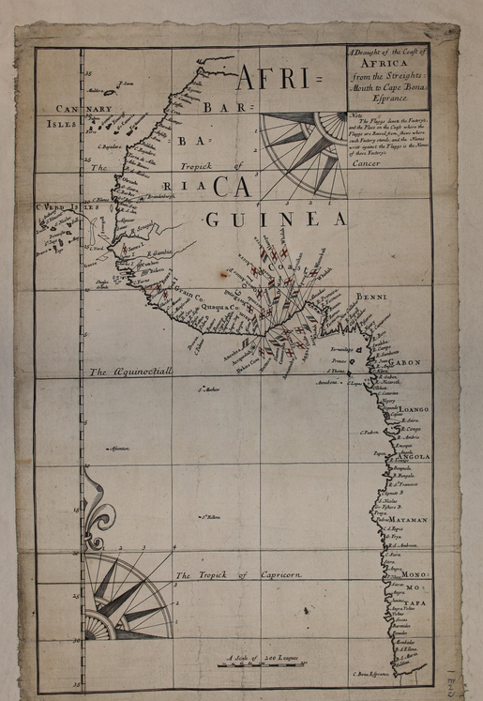
This guide will take you through the steps needed to produce this graph:
?
?
?

Graph A
Graph A follows one possible line of enquiry suggested by the Source - British Map of the Coast of Africa, 1663-1681.

Using the database we can verify that the British were the most active nation on the Gold Coast in this period.

After following these steps to produce your own version of this graph you can then formulate your own enquiry and graph set.

Tasks

Follow the steps below to re-create Graph A above.

- Which was the second most active trading nation 1663-1681?

- Which other trading nations were active on the Gold Coast 1663-1681?

Over to you!

- Choose your own line of enquiry. Copy and paste the graphs you create into a presentation.

- Annotate your graphs with short clear explanations of what they reveal of importance to a Historian studying the Slave Trade

- Step1 – click on the following link to visit the Voyages data base website

http://www.slavevoyages.org

- Step 2 – hover over the ‘Voyages Database’ tab and select ‘Search the voyages database’

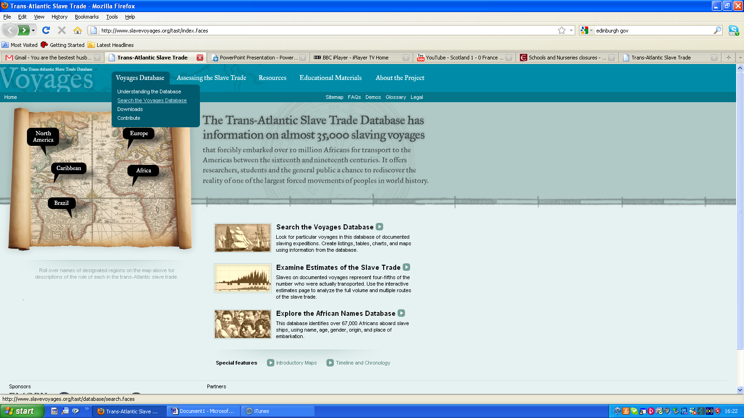

Step 3 – select the years of interest in the ‘Select time frame’ section

Match the years given in the source: (1663 -1681).

Or, when formulating your own enquiry, limit the search to a century of interest

E.g. 1700 -1800
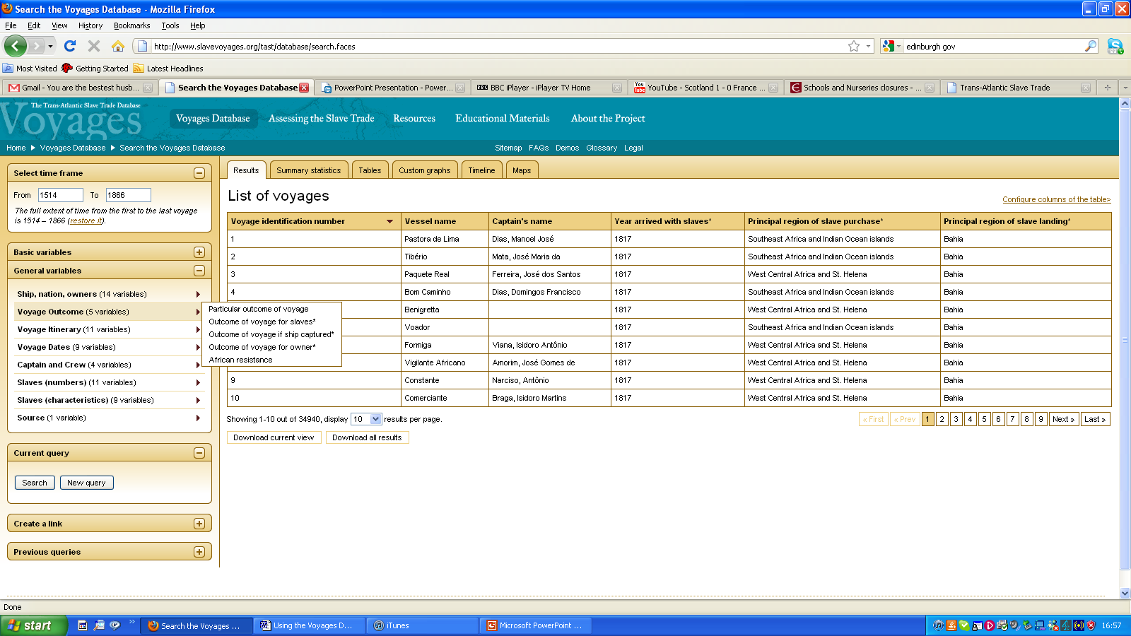

- Step 4 – select the variables of interest in the ‘General variables’ section
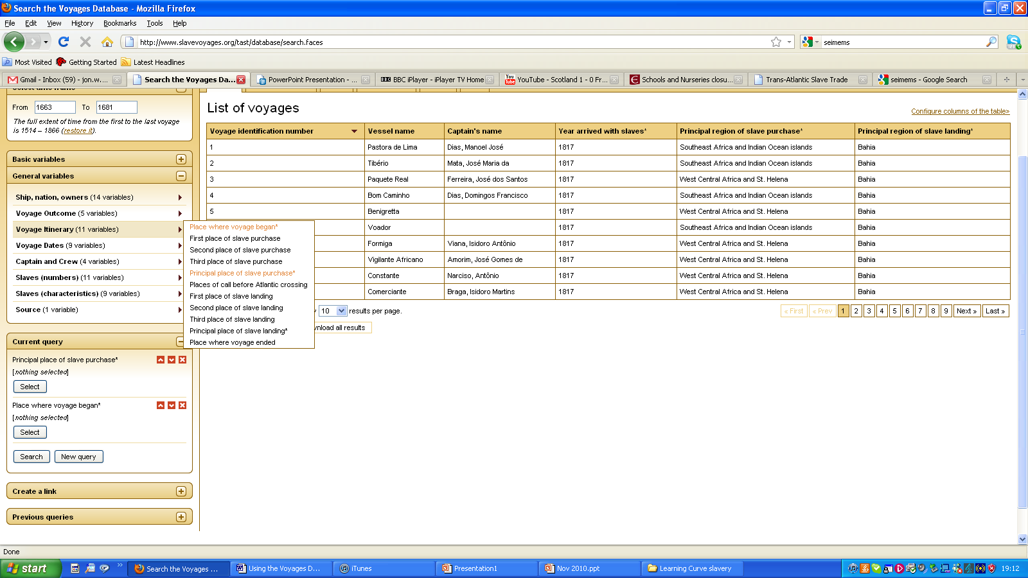
E.g. within ‘Voyage Itinerary’ select ‘Principle place of slave purchase’ and the ‘Place where voyage began’.

- Step 5 – now within the ‘Current query’ section you can limit your selection to specific locations of interest e.g. within ‘Principle place of slave purchase’ you can limit the search by selecting ‘Africa’ and the ‘Gold Coast’. And within ‘Place where voyage began’ you can select places such as ‘Europe’ and ‘Great Britain’. The Quicksearch facility is useful shortcut to type your locations into.
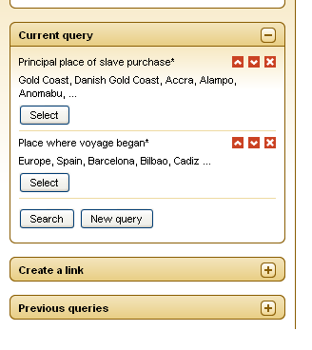

- Step 6 – When you are happy with your selections click on the OK buttons. Then click on ‘Search’ to run the query.

- Step 7 – click on the ‘Custom graphs’ tab and then select ‘Bar Graphs’
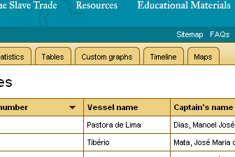

- Step 8 – Choose your X-axis, Y-axis and ‘current series’. E.g. ‘flag’ for the x-axis and ‘total slaves embarked’ for the y-axis and ‘current series’. Then click ‘Show’

- Step 9 – you should now be able to view your graph and compare and contrast the graph evidence to the source evidence.

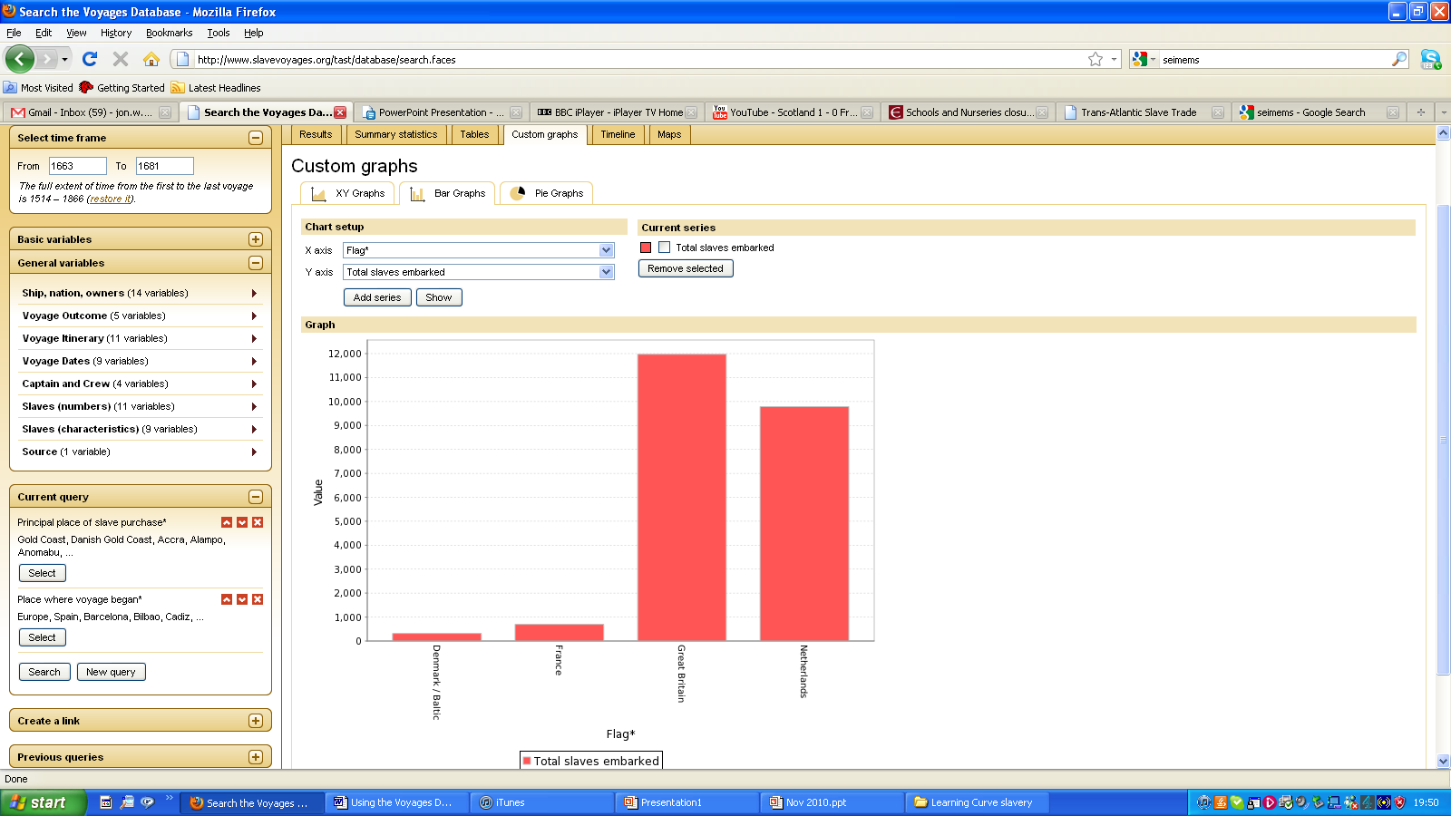

?
?
?

The above graph shows that there were 12,000 slaves embarked in the years 1663-1681 where the voyage began in Great Britain. Great Britain traded more enslaved Africans than any other European nation at this time.

